STOP!
Please ensure that the following requirements are met before proceeding:
- Local laptop or PC with RS232 Serial Port set on COM1 to be used to communicate with the RDU.
- Test cable p/n 931407-100-1 or similar. (See Drawing)
- Zip file(s) retrieved from myairshow.rockwellcollins.com identified in Step 3.
- NOTE that aircraft does not need to be outside (have access to the satellite line of sight) to update and load the latest channel list.
STEP 1
Power off RDU – pull off circuit breaker.

STEP 2
Identify your RDU system from the following list below:

RDU (p/n 931000-xxx) | Region | Satellite | Region Code
-200 | Dual Common Interface | Multi Region
-201 | Dual US | DirecTV / DirecTV | 10
-202 | US / Common Interface | DirecTV / Multi Region | 10/xx
-204 | Europe | Astra | 14
-205 | Europe | Hotbird | 11
-206 | Europe | Astra / CanalSat | 14
-207 ¹ / -208 | Middle East | Nilesat | 13
-210 | India | NSS06 | 12
-212 | Middle East | Arabsat | 18
-214 ² | Russia | Eutelsat W4 | 17
-215 ² | China | Telstar 18 | 19
-220 | US / EU | DirecTV / Hotbird | 10/11
-227 | EU / ME | Hotbird / Nilesat | 11/13
Notes: 1 -207 (Nilesat) is obsolete.
2 RDU Service Bulletin 10 must be installed prior to installation of this Region Kit.

STEP 3
Go to myairshow.rockwellcollins.com and sign in with your username and password.
Navigate to Tailwind TV tab
Download and save the appropriate .zip file(s) onto your local laptop or PC based on your RDU configuration (as seen below). Note only down load channel database files labeled as standard definition (SD).
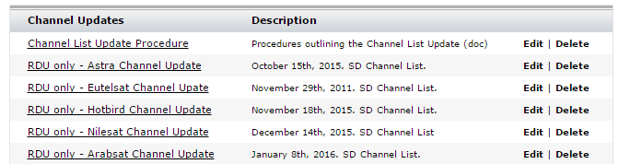
*In the US region, channels are updated automatically and do not require these steps.

STEP 4
Extract the .zip file for the RDU receiver that requires a channel list update into a new folder.

STEP 5

Obtain Test Cable p/n 931407-100-1. Connect 1P2 connector of test cable to the RDU front connector (or to the RDU maintenance port in the cabin).

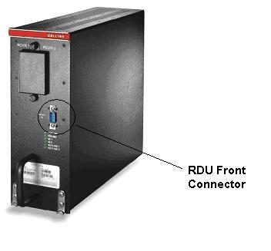

STEP 6

Each RDU contains 2 Receiver Cards located in either slot RCVR1 or RCVR2 (see table below). For example, RDU -227 contains 1 European card in slot RCVR1 and 1 Middle East Nilesat card in slot RCVR2.

LRU  PORT | RDU P/N  931000-205 | RDU P/N  931000-208 | RDU P/N  931000-212 | RDU P/N  931000-220 | RDU P/N  931000-227
RCVR1 | EU-Hotbird | ME-Nilesat | ME-Arabsat | - | EU
RCVR2 | EU-Hotbird | ME-Nilesat | ME-Arabsat | EU | ME-Nilesat

1) To update channel list for card located in Receiver slot #1:

Connect RCVR 1 (from test cable) to the laptop or PC serial port COM1.

2) To update channel list for card located in Receiver slot #2:

Connect RCVR 2 (from test cable) to the laptop or PC serial port COM1.

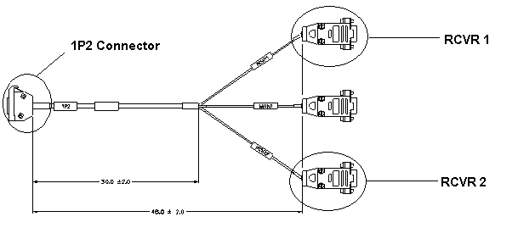
Test Cable part no. 931407-100-1

STEP 7

Power up RDU and wait until you see picture available on screen.

STEP 8

Extract the downloaded *.zip file from Step 3. Within the extracted folders, you'll find documents listing updated channel numbers and channel names. You'll use this to verify the update was successful. Proceed by verifying you have an RDU with or without Mod G.

- RDU's Pre-Mod G – Technisat IRD
  - Enter the folder for Pre-Mod G RDU's and click on the *.BAT file. A DOS window should appear on the PC screen and the picture from the RDU should disappear. Then, the DOS window should disappear and the picture should come back on. The channel list upload should now be complete.
  - Note – this BAT file (Sometimes shown as “Windows Batch File”) is hard coded to use Com1 – If you are using another Com port, edit the *.BAT / Windows Batch File using Windows Notepad
    - Default Example for Com 1: putprog.exe -p 1 -f nilesat.txt
    - Edited to use Com 3: putprog.exe -p 3 -f nilesat.txt
- RDU's with Mod G – Fortec IRD
  - Enter the folder for Mod G RDU's and run the Platinum Uploader program
  - Click “Browse” and locate the *.cdf file contained in the same folder.
  - Click “Download” - You will see the application identify the RDU/IRD
    - If the program is alternating between available Com ports, i.e. Com1, Com2 for more than a few seconds, you may have a communications issue, verify the proper connections.
  - Click “START” - The channel listings will be pushed to the IRD

STEP 9

Check TV channels to ensure that it matches the latest channel list document provided in the downloaded channel update.

STEP 10

Repeat STEP 6 accordingly if more than 1 RDU card requires an update.

Please contact your designated Rockwell Collins Customer Support Engineer (CSE) for questions and assistance. Or send an email to our customer support center at AvionicsSupport@rockwellcollins.com

