For your convenience, below are instructions for using the United Technologies/LexisNexis Contractor Screening system. These instructions detail steps to follow when performing the key activities which include:

Table of Contents
I. New Account Registration
II. Login to the Website
- Add a Person / Employee
- Submitting an Order
V. Search for a Person / Employee and Viewing Compliance
VI. Terminate/Inactivate an Employee
VII. Add a New Location
VIII. Add a New User
IX. Authorization
X. Contractor form

For assistance, you can contact the LexisNexis Customer Support team at : 1-866-441-5290 or by email at utccontractors@lexisnexis.com

- New Account Registration

Access the Contractor Screening System at: https://contractor.lexisnexis.com/CS/unitedtechnologies

NOTE: You may want to bookmark this URL in your browser. Make sure that it is entered exactly as provided - all lowercase letters should be entered lowercase, all capital letters entered as capitals.

- Select the “Click here to Register as an Agency” link at the bottom of the screen. The Contractor Registration screen will then be displayed.

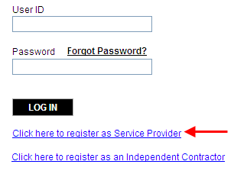
- Create a User ID and Password and enter in Business Information. All fields with an asterisk are required.

- Enter the Primary Contact Information for the person who will be the main contact at the firm. If you do not have an email address, you need to setup an account. Free email is available from Hotmail or Yahoo.

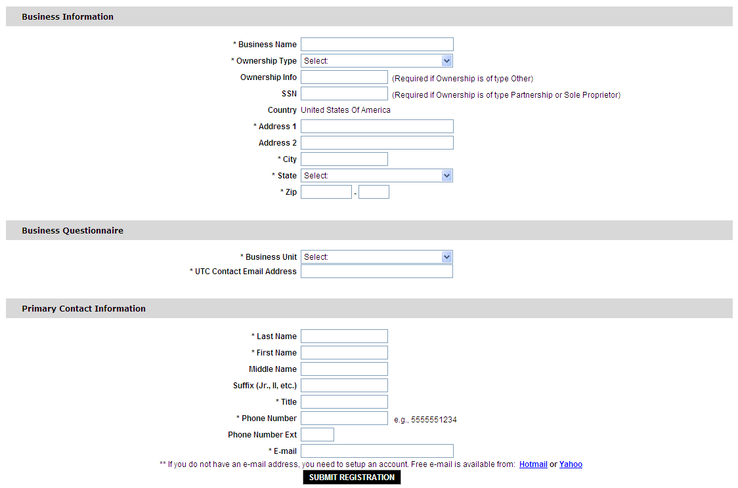
- Once all information is entered, select SUBMIT REGISTRATION.

- On the next screen, review information entered. If corrections are required, click “GO BACK”. If all information is correct, click “CONFIRM”.

- A message will show that you have been registered successfully with a transaction number for your reference. You will also receive an email confirmation of your registration. This can take 1 to 3 business days for LexisNexis to finish set up.

II. Login to the Website

Access the Contractor Screening System at: https://contractor.lexisnexis.com/CS/unitedtechnologies
- . Be sure that it is entered exactly as provided - all lowercase letters should be entered lowercase, all capital letters entered as capitals.

- Login using your User ID and Password you created during the initial registration process.

- On your first login to the system, you will be presented a Legal Agreement. Read this information carefully. If you accept, click on “ACCEPT LEGAL AGREEMENT” button to proceed. You will not see this Legal Agreement going forward.

- Next, you will see the Fair Credit Reporting Act (FCRA) certification screen. Read this information carefully and select the “ACCEPT FCRA AGREEMENT” button if you agree to the terms and to proceed. This acceptance will be required each time you log into the system.

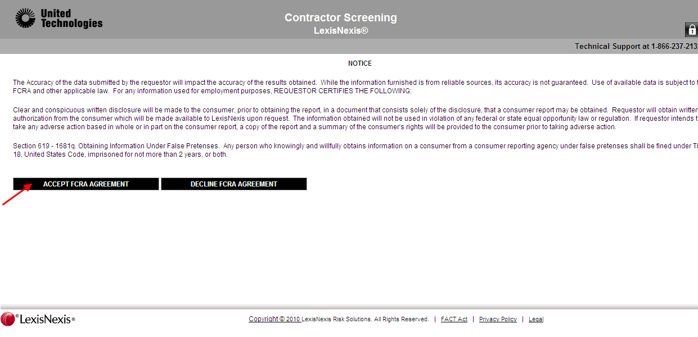

- You will now be at the home page for Contractor Screening. After login, you may perform various tasks such as:

- Add a Person / Employee
- Submitting an Order
- Search for a Person / Employee and View Compliance
- Edit Employee Status

NOTE: Your account will be activated for ordering in 1-2 business days from the time you register.

III. Add a Person/Employee

- Select the PEOPLE > ADD NEW PERSON option from the drop down the menu near the top of the screen.
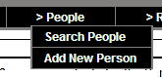
- On the Person Information screen, enter the person’s information. Required fields are noted with asterisks. When complete, click “SAVE”. The Person is immediately added to the roster.

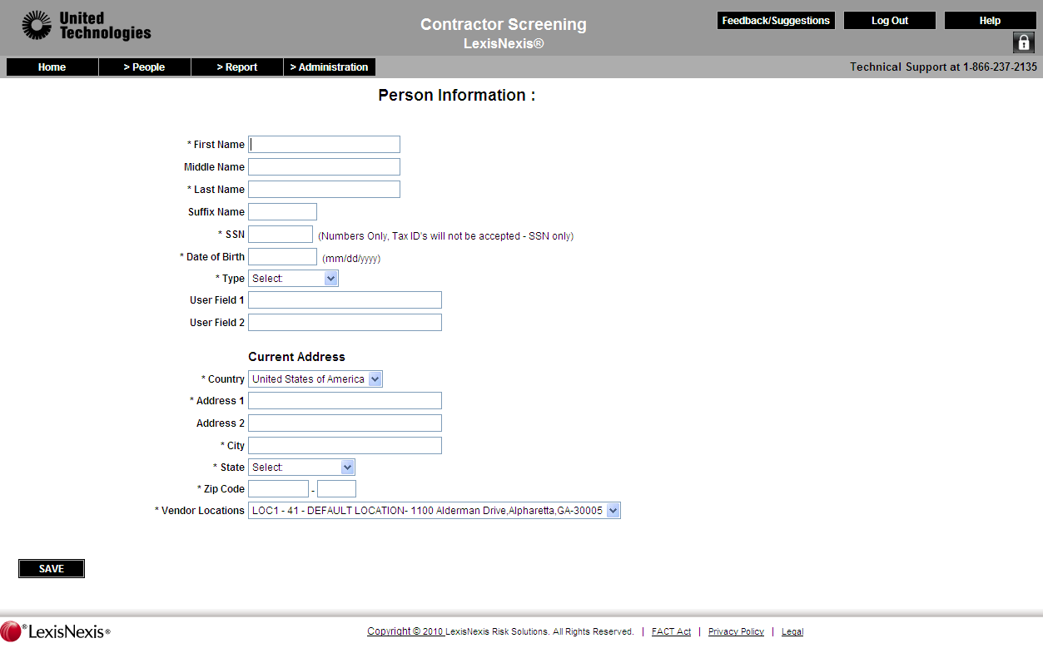
Make sure all information entered is correct before pressing Save!

IMPORTANT: BE SURE THAT YOU HAVE A SIGNED AUTHORIZATION FROM THE APPLICANT (CONTRACTOR) BEFORE RUNNING ANY BACKGROUND CHECK.

IV. Submitting an Order

- On the Person Status Detail page, select the BEGIN ORDER PROCESS button.

NOTE: If you are not on the “Person Status Detail” page, go to PEOPLE > SEARCH PEOPLE menu option, enter the name of the person you wish to submit an order for and select SEARCH, and then click the person’s name in the result grid.
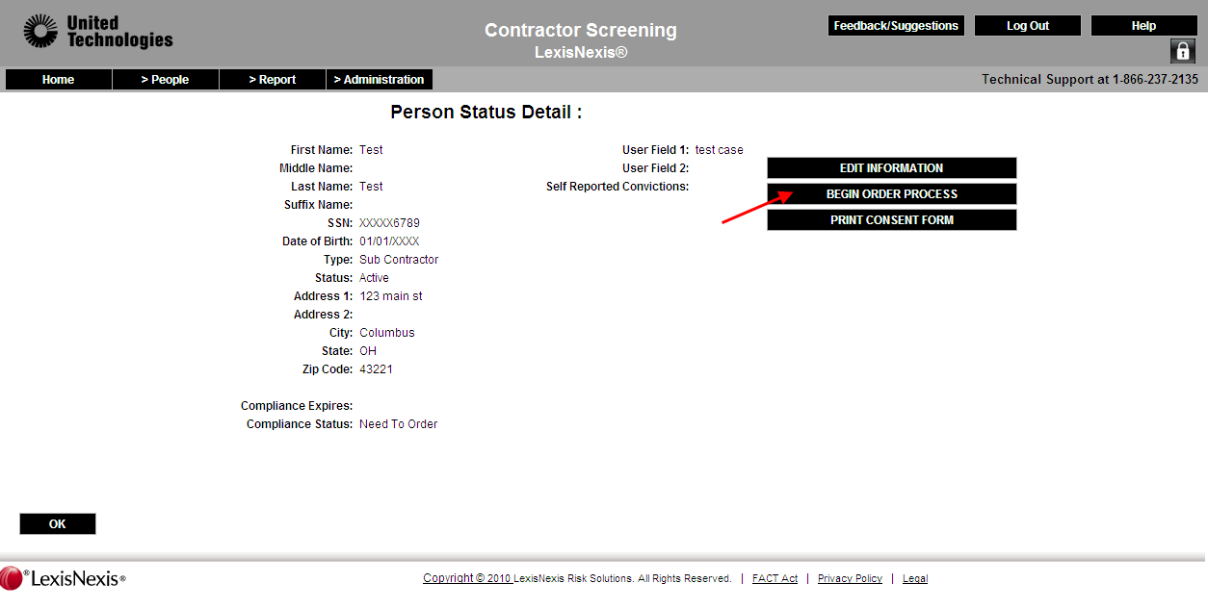

- The system then displays the Background Check Order Detail page which allows you to select the screening package. Once you select the package, the package details are displayed for review. Make sure you have a signed consent form from the person before a Background Screen is ordered. You can click on the consent form hyperlink and print one off of the site. Check consent confirmation checkbox, then “Next”.

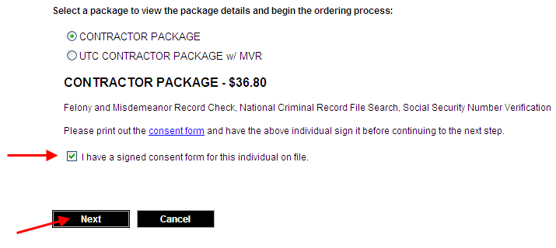

- You will then be prompted to any Previous Address history and/or any Previous Convictions. After that is complete, click ‘NEXT’.

- The below payment screen will be displayed. Select a payment method and enter any required information.

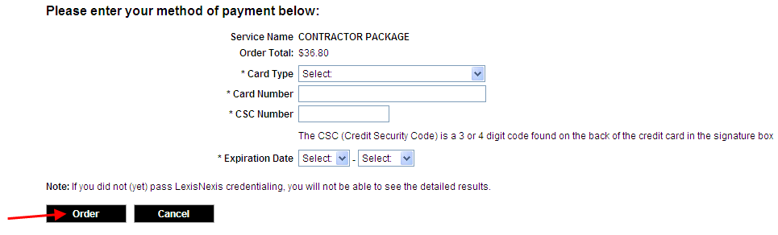

- Once all payment information is entered, select ORDER.

Note: The order is now being processed. Completion of screening is primarily based on items included in the screening package.

V. Search for a Person / Employee and Viewing Compliance

- Go to the PEOPLE > SEARCH PEOPLE menu option.
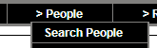

- Search by entering one or many of the desired search criteria - typically an individuals SSN or name. Partial search data may also be used. When search information is entered, click SEARCH. If no search criteria are entered, the system will display a complete list of all individuals added within your account.
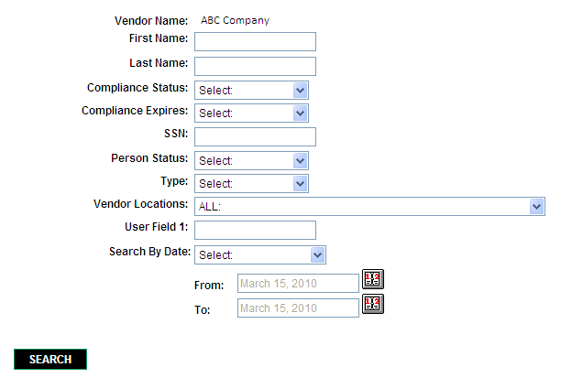
- After selecting SEARCH, the results will appear at the bottom of the page. This screen can be used to quickly confirm a “Compliance Status”.

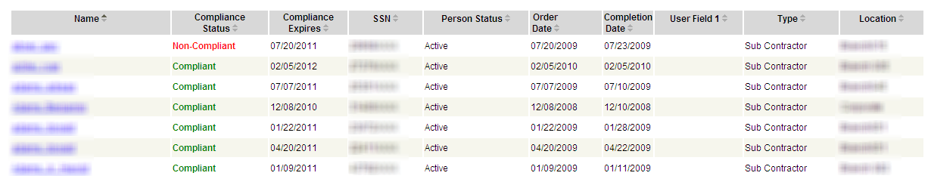

- Review the search results to locate the person you were searching for. If the person was not located, you may need to add the person to the system and submit an order.

- The People Roster may be sorted by the fields by clicking the arrows beside each field descriptor. Also, SSN’s will be masked for privacy.

Note: A Person must be added to the system before a screen may be ordered.

VI. Terminate/Inactivate an Employee

- Search for the person whose status you would like to change by going to the PEOPLE > SEARCH PEOPLE menu option.

- Search by entering one or many of the desired search criteria - typically an individual’s SSN or name. A partial search data may also be used. When search information is entered, click SEARCH.

- Next, select the person’s name in the result grid to view their profile.

- Select EDIT INFORMATION.
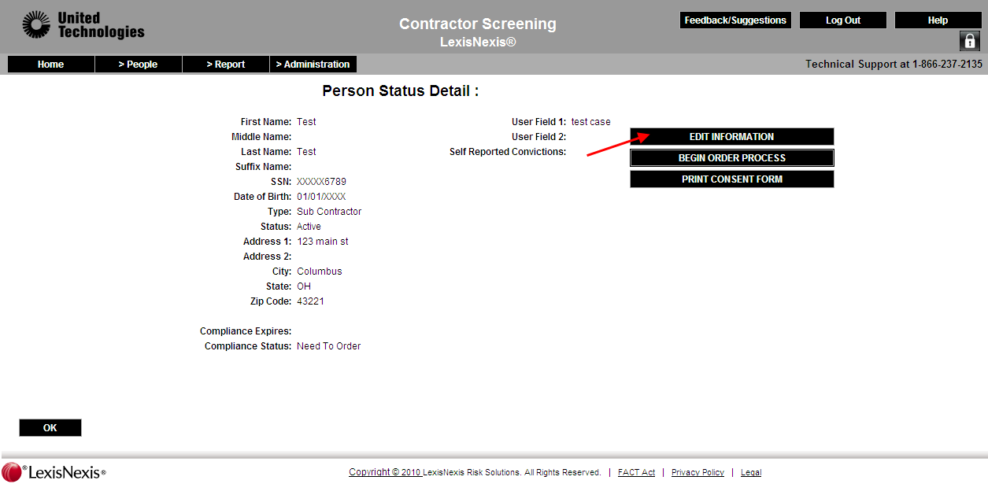

- For changing the person’s status, go to the drop-down menu labeled “Active Status”. Click on the drop-down to select the new status in which you would like to place the individual.
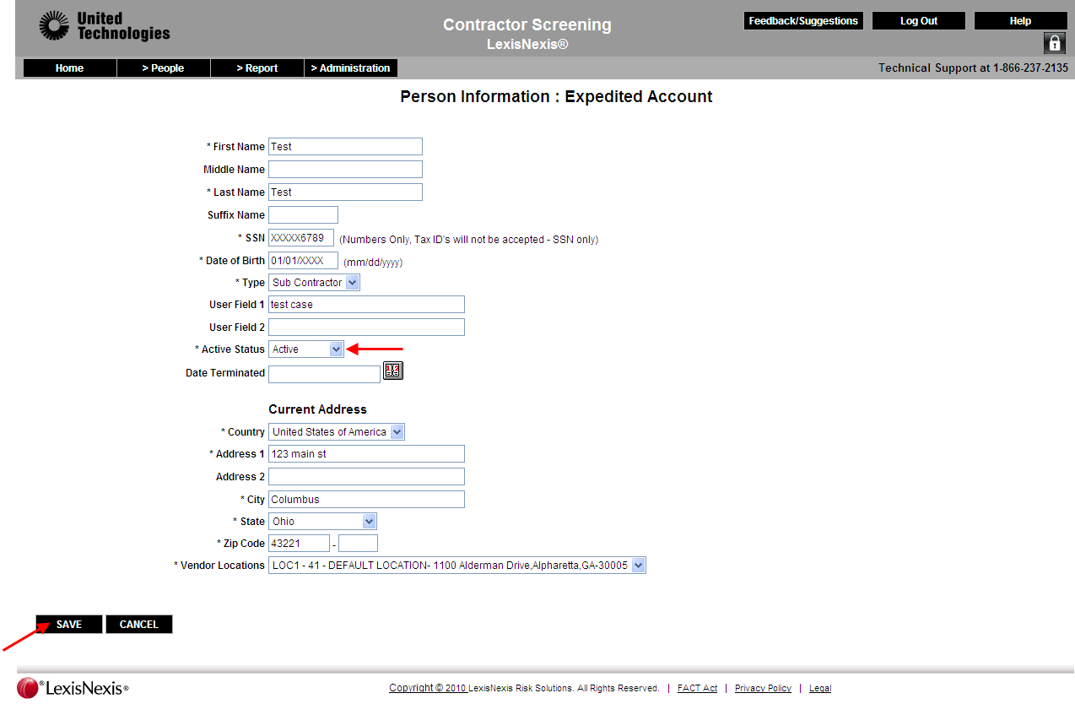

- Click the SAVE button at the bottom of the page to complete the change (click cancel to return to the previous page).

VII. Add a New Location

- Click on ADMINISTRATION>VENDOR LOCATION
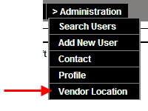
- Click on ADD NEW, enter the location Information and click SAVE. This location will then be displayed in the location drop down when adding people to the roster.

VIII. Add a New User

- Click on ADMINISTRATION>ADD NEW USER.
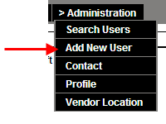

- Create a User ID and Password for the individual and set their Role (Admin, View, Update, Summary) with the level of access that you determine to be necessary.

IX. Consumer Notification & Authorization

This is used to inform you that a consumer report or an investigative consumer report is being obtained from a consumer reporting agency for the purpose of evaluating a contracting engagement at United Technologies and / or any of their subsidiaries.

This report may contain information bearing on your credit worthiness, credit standing, credit capacity, character, general reputation, personal characteristics, or mode of living from public record sources or through personal interviews with your neighbors, friends or associates. You may also have a right to request additional disclosures regarding the nature and scope of the investigation.

TO Whom it May Concern:
I hereby authorize and request any present or former employer, school, police department, financial institution, agency or other persons having personal knowledge about me, to furnish bearer with any and all information in their possession regarding me in connection with an application for employment, including consumer report information that may include motor vehicle records. I am willing that a photocopy of this authorization be accepted with the same authority as the original, and I specifically waive any written notice from any present or former employer who may provide information based upon this authorized request. I understand this authorization is to be part of the written employment application which I sign.

I have been given a copy of this form.

Print Name: ____________________________________________________________

Signature: ______________________________________________________________

Date of Birth (for identification purposes only):________/__________/______________

Social Security Number (for identification purposes only): ______-______-__________

List any other names previously used and dates when they were used:

Name: ______________________________________ From: _________ to _________

Name: ______________________________________ From: _________ to _________

Name: ______________________________________ From: _________ to _________

MN & Oklahoma Residents, please note: In connection with your application for employment, your consumer report may be obtained and reviewed. Under Minnesota and Oklahoma law, you have a right to receive a free copy of your consumer report by checking the appropriate box below.

___ YES, I am a Minnesota resident and would like a free copy of my consumer report.
___ YES, I am an Oklahoma resident and would like a free copy of my consumer report.

CA Residents please note: In connection with your application for employment, your credit report will be obtained and reviewed. Under CA law, you have a right to receive a free copy of your credit report by checking the appropriate box below. Your credit report will be mailed to you by the credit bureau. In the alternative, you may elect to receive the entire investigative consumer report, which will include your credit report.
___ YES, I am a California resident and would like a free copy of my credit report; or
___ YES, I am a California resident and would like a free copy of my investigative consumer report.

X. Contractor Information Form

You can use this form to gather the information you need to enter the background:

Applicant Name: ___________________,_______________,________________
Last First Middle

Previous Legal Name: ____________________,______________,___________
Last First Middle

Social Security #: _________-_______-____________

Date of Birth: ________/________/_____________
(Identification purposes only-Include Month/Day/Year)

Drivers’ License #: ____________________________ State Issued: ________

YOU MUST ORDER ALL COUNTIES OF RESIDENCE USED IN PAST 5 YEARS

Current Address:

Street Address_________________________________ From: ______to______

City_____________________________ State__________ Zip Code_________
Previous Addresses:

Street Address_________________________________ From: ______to______

City_____________________________ State__________ Zip Code_________

Street Address_________________________________ From: ______to______

City_____________________________ State__________ Zip Code_________

Street Address_________________________________ From: ______to______

City_____________________________ State__________ Zip Code__________

