Title | Document ID | MFT-EXT
Customer/Supplier Guide for MFT/MoveIT File Exchange | Version | 1
 | Last Revised Date | 10/20/2020
 | Last Revised By: | Kara Bazzano & Nicholas Wynne
 | Last Rev Description: | Initial Revision

Table of Contents
1. Purpose & FAQs 1
2. Folder Setup / USer creation 2
3. Accessing MFT 2
3.1. Left Toolbar 3
3.2. Top Toolbar 3
3.3. Center Screen 3
4. Folder Structure 3
5. Uploading and Downloading Files 4
5.1. Uploading ToUTAS 4
5.2. Downloading FromUTAS 6

Purpose & FAQs
The purpose of this document is to show a customer or supplier how to use MFT / MoveIT.

What is MFT / MoveIT?
MOVEit™ is a secure Managed File Transfer (MFT) file transfer system allowing external users to manage, view and control file transfer activity. MOVEit™ is managed by RTX and used by all RTX divisions to transfer data internally and externally.

Is it called MFT or MoveIT?
Most Collins employees refer to the system as MFT, but the two terms are used interchangeably. For the purposes of this document, we’ll use the abbreviation of MFT.

Does MFT replace Content Server for file exchange?
Yes. Content Server is due to be retired on January 25th, 2021.

What are the main differences between Content Server and MFT?
Content Server retained files forever. MFT automatically deletes files seven days after they are uploaded to minimize the risk of a damaging data breach to Collins Aerospace.
How do I get access to MFT?
In order to get access to MFT, a Collins employee must request access through an external workflow. Once this has been approved you will receive credentials from the Collins employee.

How do I create folders in MFT?
Folders will be created by a Collins employee. There will be a folder that has ToUTAS. This is where files will be dropped.

Folder Setup / USer creation
Collins employees must set up external users with folders and accounts in MFT prior to sending files. Once created, the Collins employee will either provide the user with a username and password, or notify the user to use their existing UTC LDAP credentials.

If you are working with a Collins employee who is unaware how to create folders and accounts for your project, you can direct them to the access workflows here: https://global.utas.utc.com/sites/it/services/MFT/Pages/default.aspx.

Accessing MFT
Once your credentials have been given to you, log onto MFT using the folder URL given to you by the Collins employee assisting you with this effort..

Once within the system, we can familiarize ourselves with the MFT homepage:
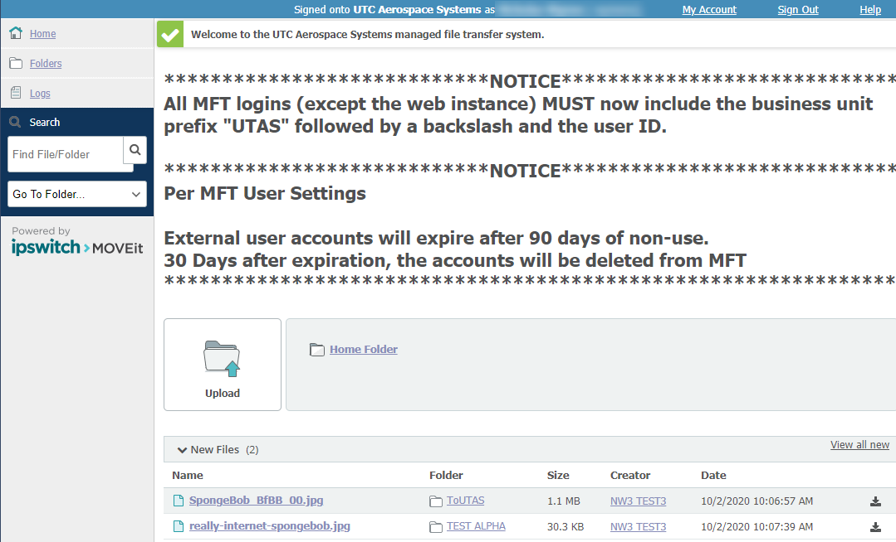

Left Toolbar
On the left side of the screen, you’ll see a toolbar with different options:

- Home
- Folders – Will take you to the folders that you have access to
- Logs – Will take you to the logging, reporting, and auditing tools
- Search
      - Find File/Folder – Search for a specific file or folder
      - Go To Folder – Select a specific folder from the list of your folders

Top Toolbar

- My Account – Edit language and display settings here (do not edit email or multi-factor auth)
- Sign Out
- Help – This info is generic and may not reflect how Collins has configured this app

Center Screen
- Upload – Begins upload process
- New Files – Displays recent files

Folder Structure
On the left toolbar, click Folders.

This will bring up all folders that you have access to.

Folders will follow this naming convention:

IncomingInformation-OutgoingRecipient_ShortName-PrimaryProtocol-US-ExportControlled(Y/N)
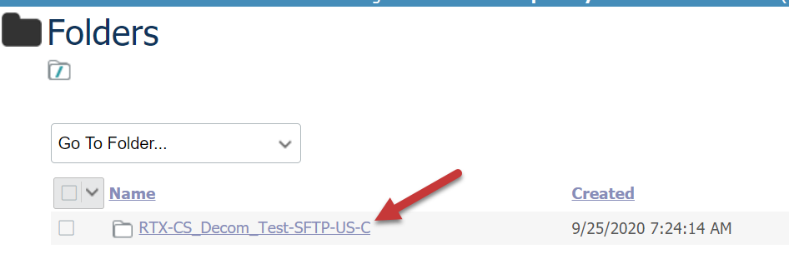
****Note that these folder names are created as part of the workflow process****

Parent level folder names cannot be altered.

Subfolders can be created within a folder.

Each parent folder contains three different sub folders by default:
- FromUTAS – Outbound. Files must be uploaded here to be sent to external users. Externals can see and download files, but can’t upload here.

- SITEADMIN – Contains external credentials. External users without an LDAP account have a username and password created after the workflow. Employees must manually send this info to the external users.

- ToUTAS – Inbound. External users upload files here to send to Collins employees. Employees can see and download files, but can’t upload here.
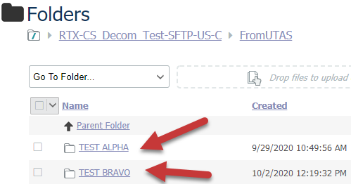

Sub-folders can be created within FromUTAS and ToUTAS.

To have the same sub-folder in both, you’ll need to create it in both.

You cannot create unique permissions for sub-folders.

Only parent folders can have unique permissions.

Uploading and Downloading Files

Uploading ToUTAS
Uploading files can begin in two different ways in MFT.

You can either begin with the Upload icon on the Home screen.

Or you can use the options shown below within one of your ToUTAS folders. You can either drag and drop files, or select Upload Files.
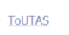
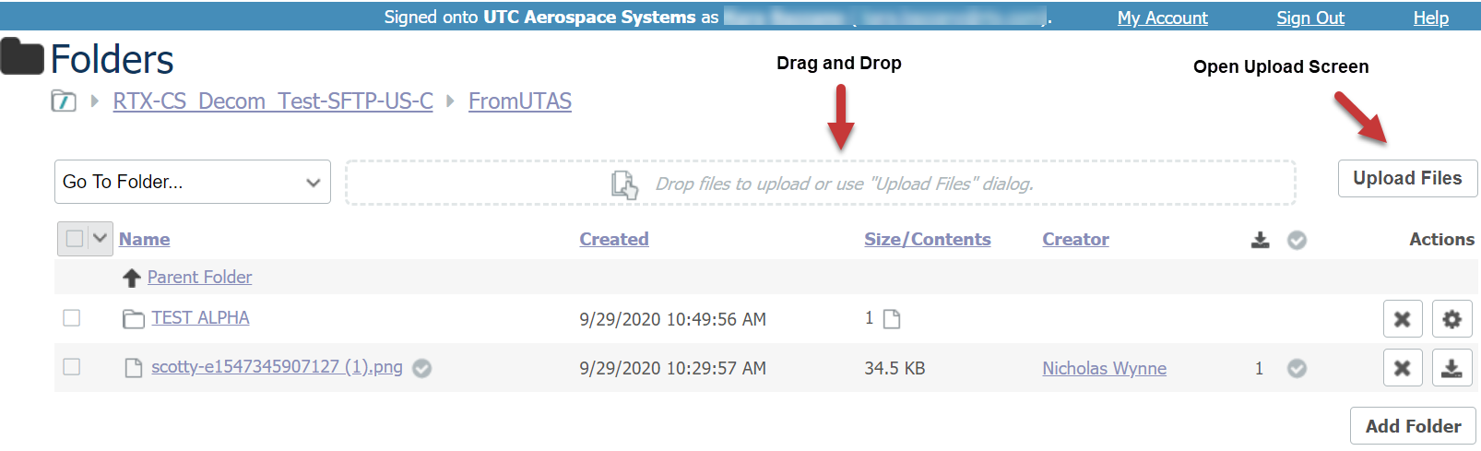
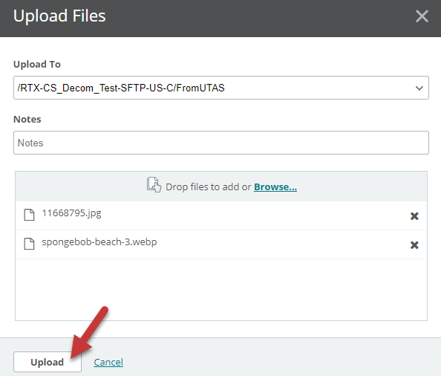
Dragging and dropping files will begin the upload immediately.
If you’ve opened Upload Files, either drag and drop your files or click Browse to find them on your computer.

Once the files are selected, they’ll appear on the Upload Files screen.

Once you are ready to begin, click Upload.

Files will be marked complete with a green checkbox.

Collins employees will receive notifications when external users upload files to the ToUTAS folder, and will need to ensure that emails from gputcmft@utc.com are not sent to junk or blocked by email settings.

Collins employees can either click the link to the folder, or the file name within their notification.

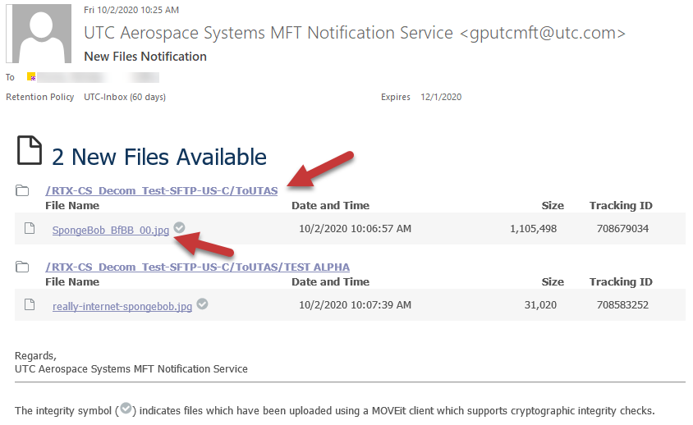

Downloading FromUTAS
External supplier and customers will receive notifications when Collins employees upload files, and will need to ensure that emails from gputcmft@utc.com are not sent to junk or blocked by email settings.
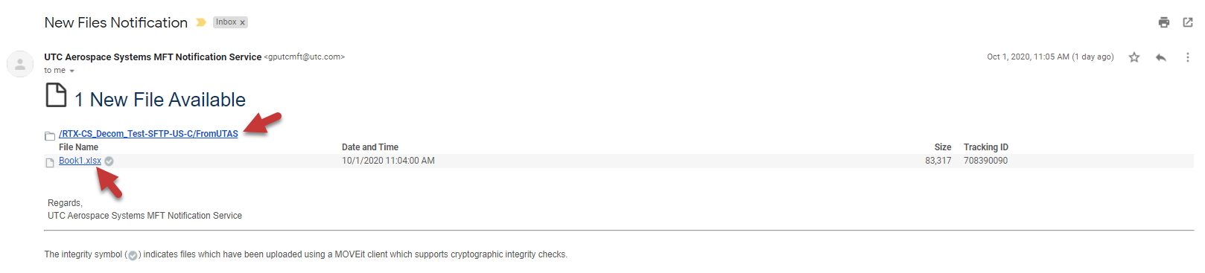
Uploaded files can also be viewed on the Home screen…
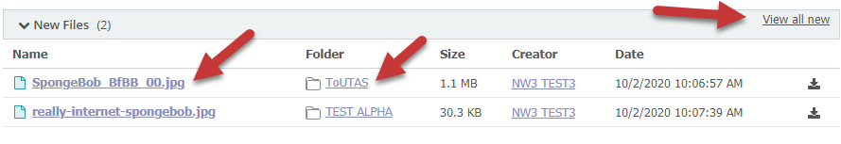Or you can navigate to the FromUTAS folder in the parent folder.

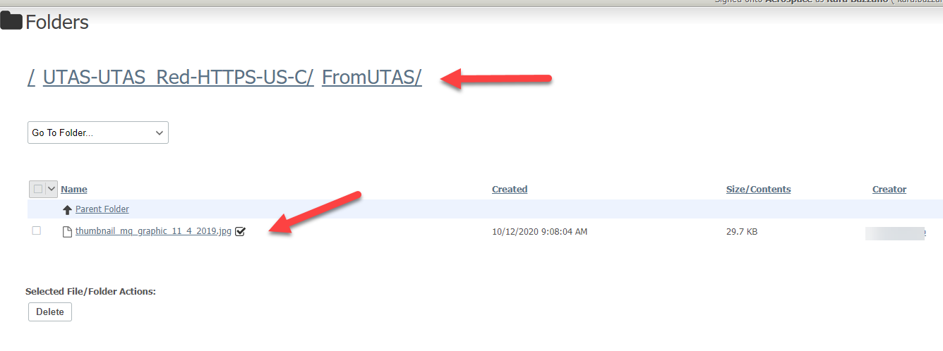
Once the file is clicked on you’ll be able to download or delete the files sent FromUTAS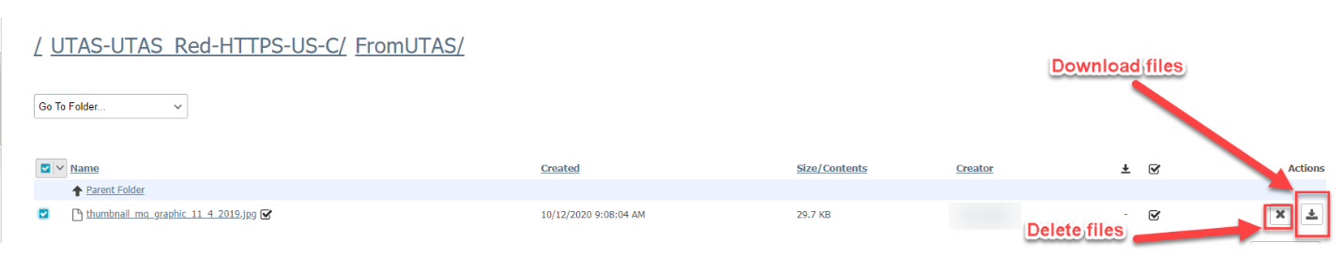

Below those options will show validation of the file’s integrity, letting you know it was securely transmitted.
Finally, a log will show some basic information on when and what has been transmitted and downloaded.

